Data scientists visualize data to understand it better. This can mean looking at the raw data, summary measures such as averages, or graphing the data. Graphs are a powerful means of viewing data, as we can discern moderately complex patterns quickly without needing to define mathematical summary measures.

Representing data visually

Representing data visually typically means graphing it. This is done to provide a fast qualitative assessment of our data, which can be useful for understanding results, finding outlier values, understanding how numbers are distributed, and so on.

While sometimes we know ahead of time what kind of graph will be most useful, other times we use graphs in an exploratory way. To understand the power of data visualization, consider the data below: the location (x,y) of a self-driving car. In its raw form, it's hard to see any real patterns. The mean or average, tells us that its path was centred around x=0.2 and y=0.3, and the range of numbers appears to be between about -2 and 2.

Representing data visually

Time Location-X Location-Y

0 0 2

1 1.682942 1.080605

2 1.818595 -0.83229

3 0.28224 -1.97998

4 -1.5136 -1.30729

5 -1.91785 0.567324

6 -0.55883 1.920341

7 1.313973 1.507805

12 0.00001 0.00001

13 0.840334 1.814894

14 1.981215 0.273474

15 1.300576 -1.51938

16 -0.57581 -1.91532

17 -1.92279 -0.55033

18 -1.50197 1.320633

19 0.299754 1.977409

20 1.825891 0.816164

If we now plot Location-X over time, we can see that we appear to have some missing values between times 7 and 12.

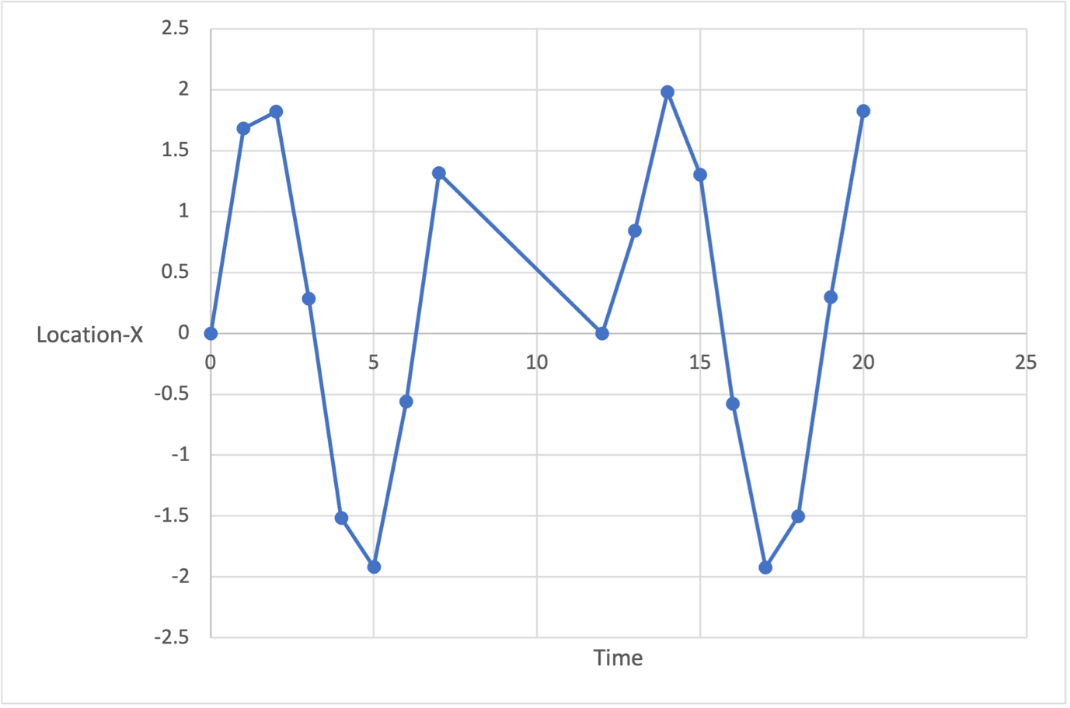

If we graph X vs Y, we end up with a map of where the car has driven. It’s instantly obvious that the car has been driving in a circle, but at some point drove to the center of that circle.

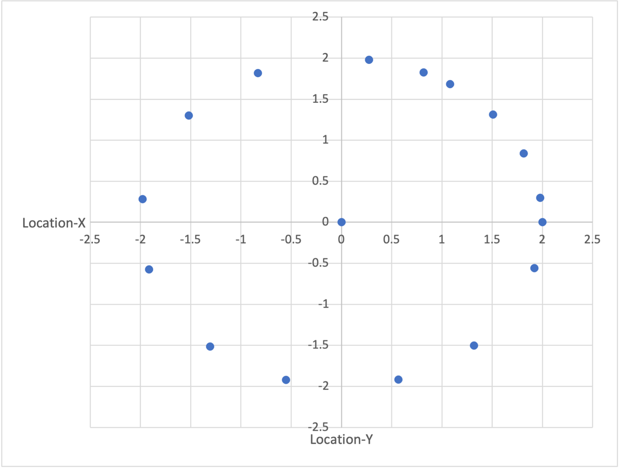

Graphs aren't limited to 2D scatter plots like those above, but can be used to explore other kinds of data, like proportions - shown through pie charts, stacked bar graphs - how data are spread - with histograms, box and whisker plots - and how two data sets differ. Often, when we're trying to understand raw data or results, we may experiment with different types of graphs until we come across one that explains the data in a visually intuitive way.